Analysing Housing Price in Metropolitan Areas of India

1.**Intoduction**:

1.2 Overview:

The sums in money for which houses may be bought or sold.

**Metropolitan areas in India are :** Chennai,Bangalore,Delhi,Kolkata,Hyderabad,Mumbai,Pune,Ahmedabad,Surat.

1.2 Purpose:

Metro cities in India are home to a large population and attract a large number of people from other regions seeking job opportunities, education, and better quality of life. The high demand for housing in these cities leads to a rise in property prices.

2.Problem Definition and Design Thinking:

2.1 Empathy Map:

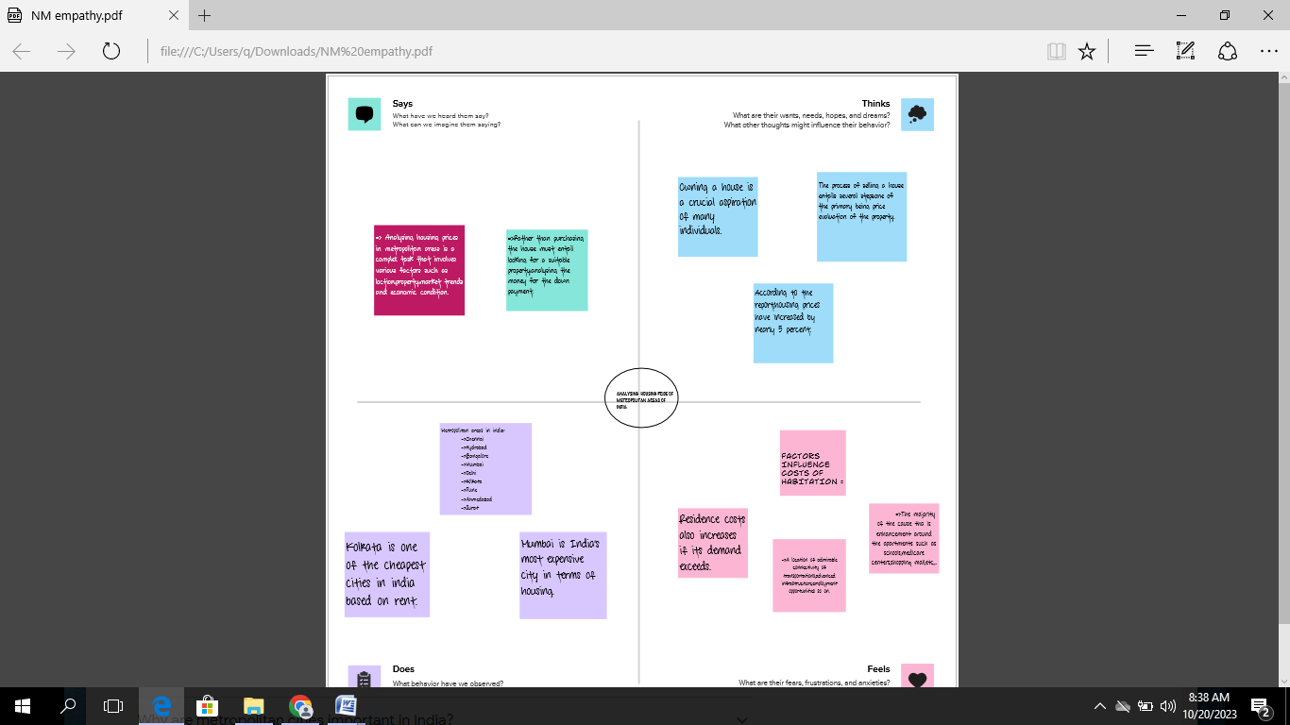

2.1 Brainstrom:

**

3**. RESULT:**

The Times of India (2012) report indicates that housing prices in India witnessed the steepest rise in the world in the last 10 years since 2001. “House prices in India have increased by 284% in real terms, after allowing for inflation — equivalent to an average annual rise of 14%. The upward movement could be due, significantly, to, rapid urbanisation, increase in population, migration from rural areas as a result of unsatisfactory performance in agriculture and expectation for better livelihood, in terms of greater earning possibilities in urban areas. Only couple of cities registered price decline in the last quarter of 2011. Hence, this paper focuses upon residential property prices in metropolitan cities in India, more specifically, on the study of fifteen metropolitan cities located at different parts of the country consisting Delhi, Mumbai, Bengaluru, Kolkata, Chennai, Jaipur, Lucknow, Hyderabad, Pune, Surat, Ahmedabad, Patna, Faridabad, Kochi and Bhopal. Due to their locations, the cities are having regional characteristics. Against this background, the basic question that arises is whether these fifteen metropolitan cities act as a single market or they work separately as segmented independent metropolitan housing markets within the country.

The result of the Im, Pesaran and Shin panel unit root test is presented in Table 1. The consistently high probabilities of the relative house prices indicate that the series is consistently non-stationary and therefore diverges indefinitely in the long-run. The lack of convergence of the relative house prices simply implies that separate metropolitan cities in India function as separate housing markets in their respective localities. In other words, the Law of One Price (LOOP) does not hold in Indian housing market case. Table 1: Im, Pesaran and Shin (2003) Test Statistic and Probabilities of Relative House Prices MAIC MSIC Statistic Prob. Statistic Prob. Constant 0.22738 0.5899 0.33900 0.6327 Constant & Trend 1.61812 0.9472 1.61812 0.9472 *, **, *** indicates statistical significance at the 10%, 5% and 1% levels, respectively.

**4. Application:**

House price prediction can help the developer determine the selling price of a house and can help the customer to arrange the right time to purchase a house. There are three factors that influence the price of a house which include physical conditions, concept and location.

## 5.Advantage and Disadvantage :

**5.1 Advantage:**

1. **Appreciation Potential:** House prices in metropolitan areas often have a higher potential for long-term appreciation due to population growth, economic development, and urbanization.
2. **Rental Income:** Investing in metropolitan areas can provide a steady stream of rental income, as there is generally a higher demand for rental properties in cities.
3. **Amenities and Infrastructure:** Metropolitan areas offer better amenities, infrastructure, and services, making them attractive to residents and tenants.
4. **Employment Opportunities:** Major cities are economic hubs with diverse employment opportunities, which can lead to higher demand for housing. It is the most important advantage to buy a home in Metropolitan City.
5. **Education and Healthcare**: Access to quality education and healthcare facilities is typically better in metropolitan areas, making them desirable for families.

**Disadvantages:**

1. **High Property Prices:** One of the most significant disadvantages is the high cost of real estate in metropolitan areas. This can be a barrier to entry for many investors and homebuyers.
2. **Competition:** Due to high demand, there can be intense competition for properties, leading to bidding wars and inflated prices.
3. **Traffic and Congestion:** Many metropolitan areas face issues of traffic congestion and limited parking, which can negatively impact the quality of life for residents.
4. **Pollution:** Pollution levels are often higher in cities, affecting air and water quality and overall health.
5. **Limited Green Spaces:** Metropolitan areas may have limited green spaces and recreational areas, making it challenging for residents to find open and natural spaces for relaxation.
6. **Cost of Living:** The cost of living in metropolitan areas can be significantly higher than in smaller towns or rural areas, impacting housing affordability. Also, the cost of living in Metropolitan Cities.

**6.Conclusion**:

This paper analyzes whether the Law of One Price (LOOP) holds in the housing market of fifteen metropolitan areas in India, namely Delhi, Mumbai, Bengaluru, Kolkata, Chennai, Jaipur, Lucknow, Hyderabad, Pune, Surat, Ahmedabad, Patna, Faridabad, Kochi and Bhopal. We test the existence of LOOP using the Im, Pesaran and Shin (2003) panel unit root test based on quarterly data on residential property prices covering the period of 2007Q1 to 2011Q4 of the Indian housing market. Based on the criterion of price convergence, house prices in the 15 metropolitan cities do not converge to the LOOP. This implies that the housing markets in the different areas operate as segmented independent local markets. Therefore, house prices in one location in India cannot impose a competitive constraint on house prices in other location, and as such a home owner can freely set the price of his house.

**7.Scope:**

The real estate industry is one of the fastest-growing industries in India and in the future, it will grow more.The Housing industry in India has caused huge venture openings since the previous decade,driven by high development because of rising interest for private just as office spaces.

This housing price prediction model acts as a hand for buyer and seller or a true realtor to form a better-informed decision. to realize this, diverse features are selected as input from feature set and various algorithms are applied like Random Forest and Decision tree.

**Submitted by:**

**POOVIKA.M**

**PANDIMEERA.S**

**NIVETHA.P**

**OVIYA.S**

**GOVERNMENT ARTS AND SCIENCE COLLEGE,ARANTHANGI**